**Articles and Reviews:**

Emphasises description with longer titles

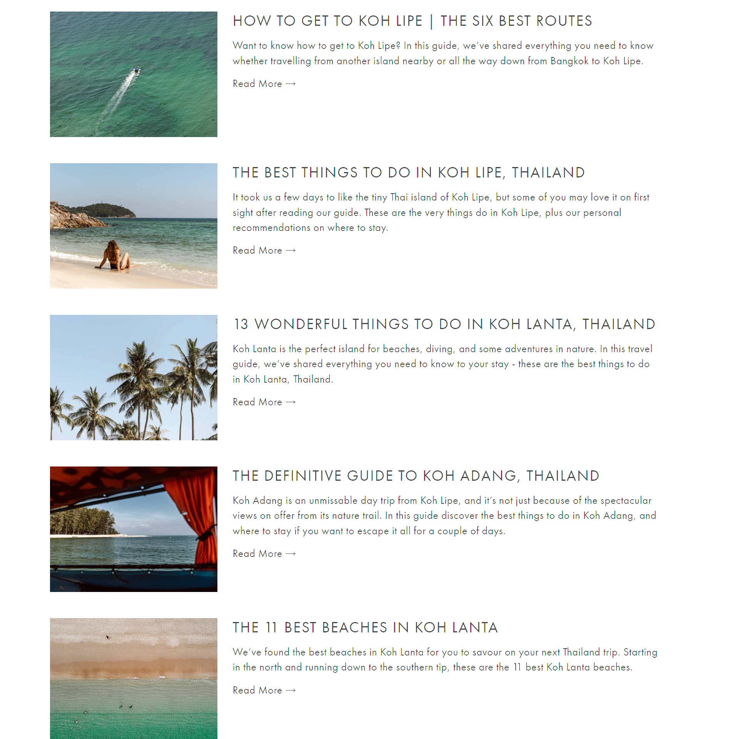

**Blog:**

Priorities images, with easily viewable descriptions, and short titles

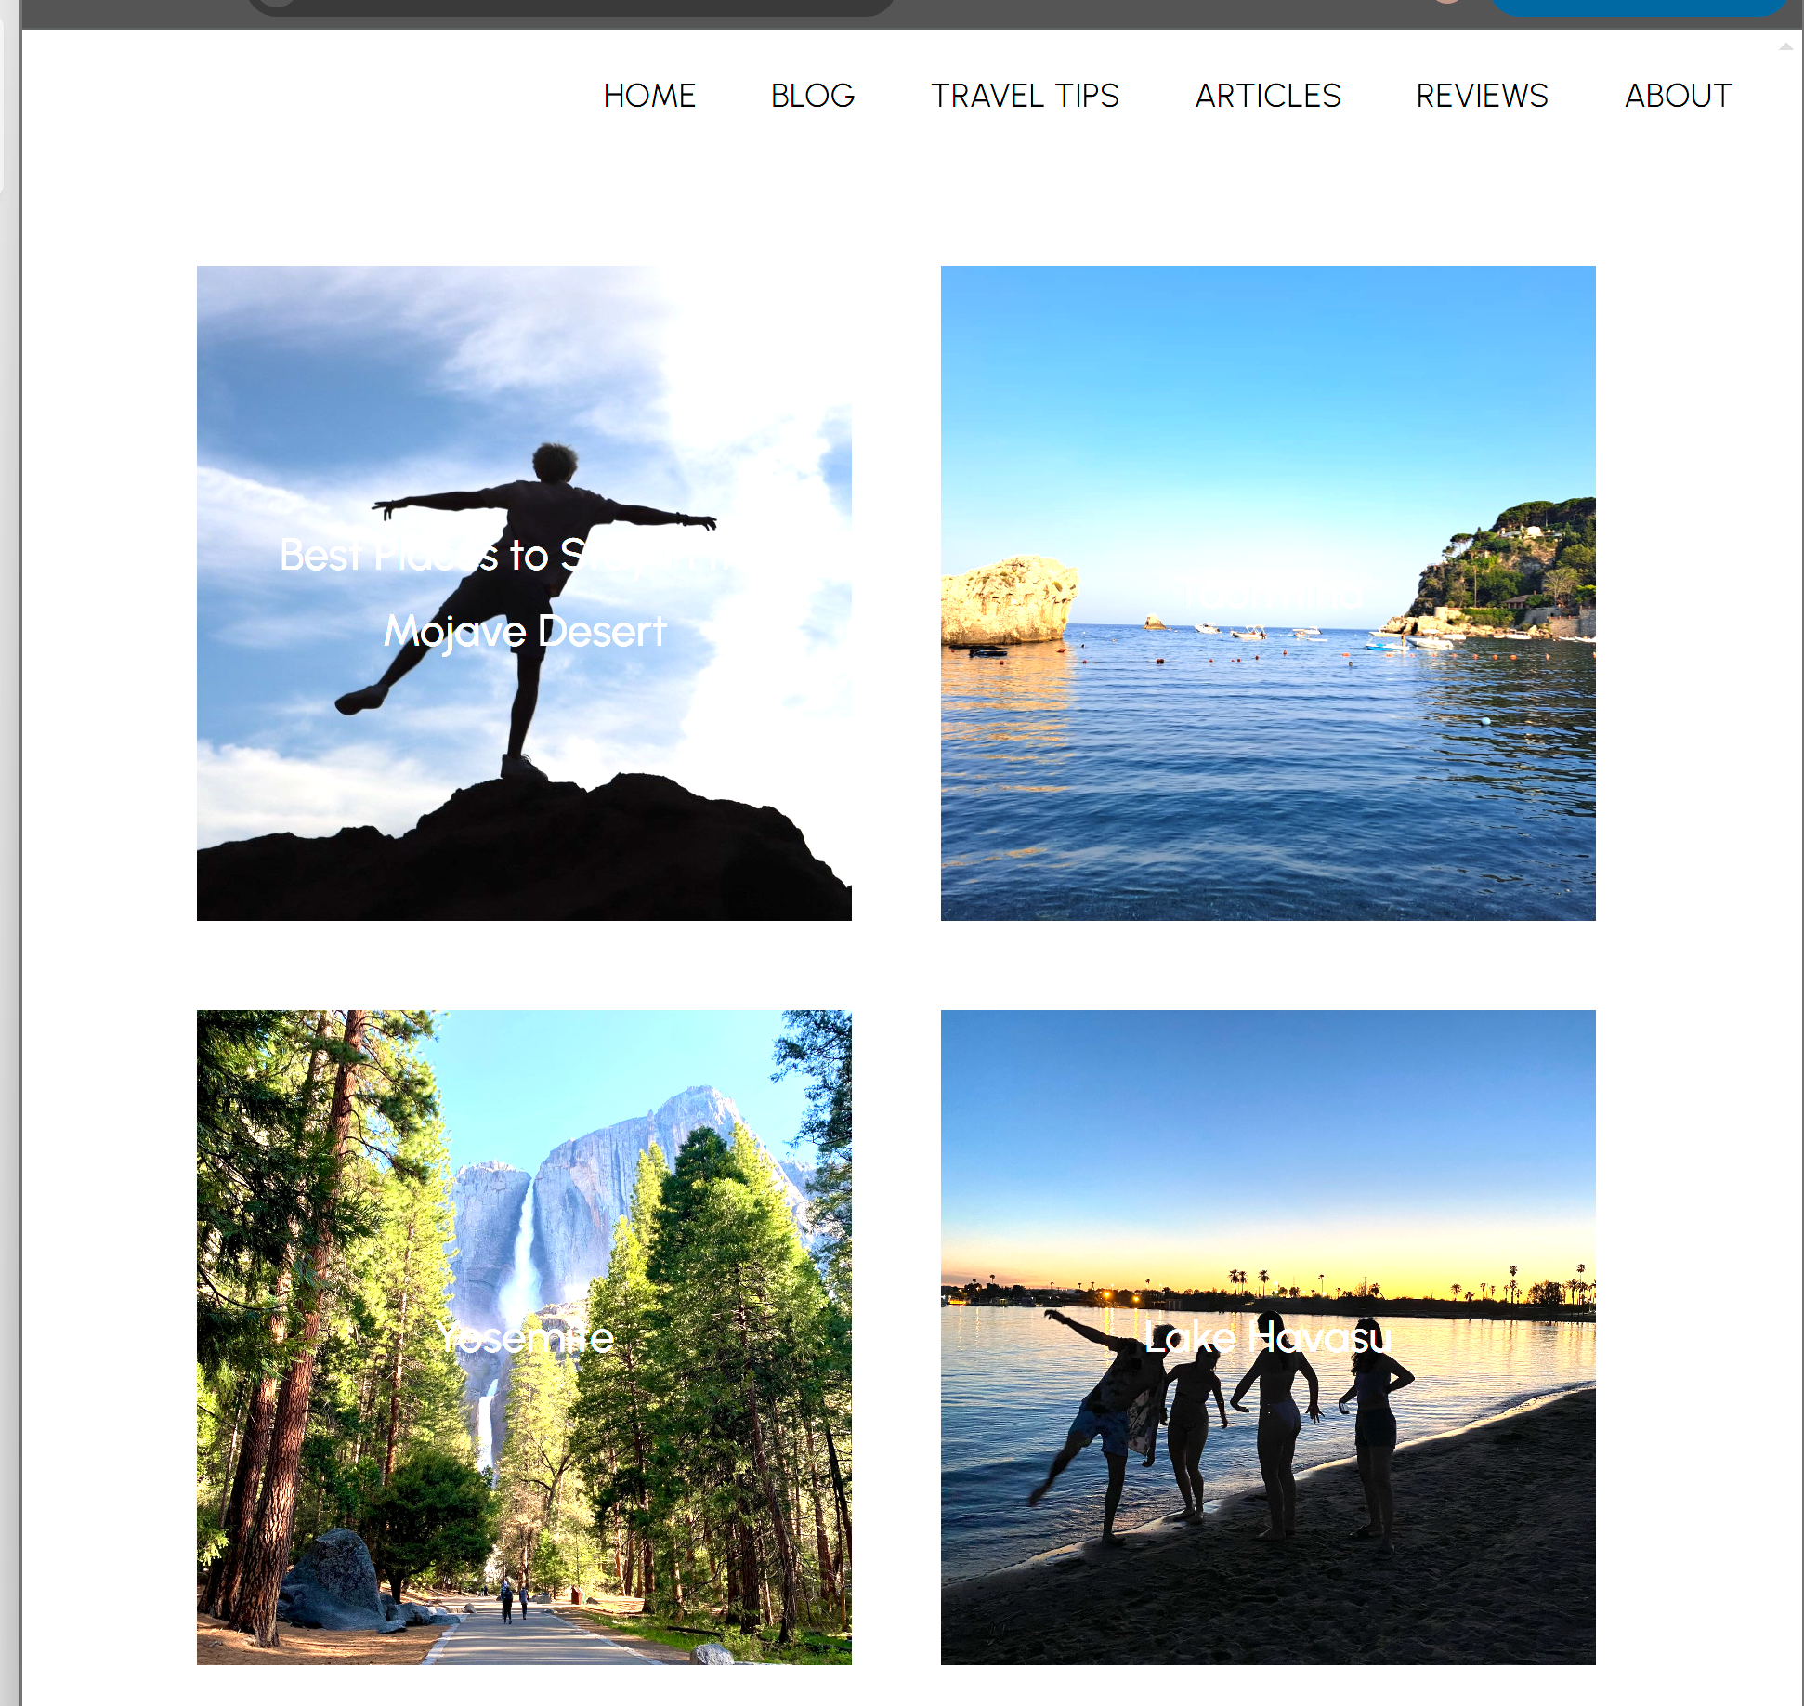

**Travel Tips:**

Same as blog but allow longer titles



**Photography:**

Minimal text, small description, short titles

